**Tutorial 7**

**Minimum Spanning and Maximum Flow**

**Minimum Spanning Problems**

**Problem One**

1. The management of a new constructed compound of large apartments is considering a walking track that will connect all the blocks and buildings of the compound. The management hopes the local citizen of will use the path or track to reach all the required facilities of the compound in a way that may reduce traffic. These are the paths or tracks in minuets taken to reach each.

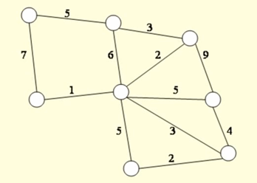

**Problem Two**

1. The management of the Dynaco manufacturing plant wants to connect the eight major manufacturing areas of its plant with a forklift route. Because the construction of such a route will take a considerable amount of plant space and disrupt normal activities, management wants to minimize the total length of the route. The following network shows the distance, in yards, between the manufacturing areas (denoted by nodes 1 through 8):

2

8

5

3

3

1

4

7

**Problem Three**

1. A major hotel chain is constructing a new resort hotel complex in Greenbranch Springs, West Virginia. The resort is in a heavily wooded area, and the developers want to preserve as much of the natural beauty as possible. To do so, the developers want to connect all the various facilities in the complex with a combination walkingriding path that will minimize the amount of pathway that will have to be cut through the woods. The following network shows possible connecting paths and corresponding distances (in yards) between the facilities: Determine the path that will connect all the facilities with the minimum amount of construction and indicate the total length of the pathway.

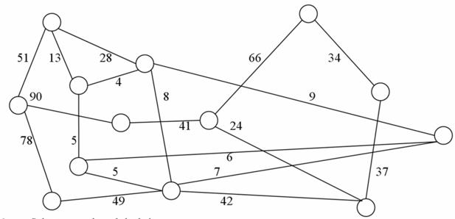

**Problem Four**

1. Several oil companies are jointly planning to build an oil pipeline to connect several southwestern, southeastern, and midwestern cities, as shown in the following network:

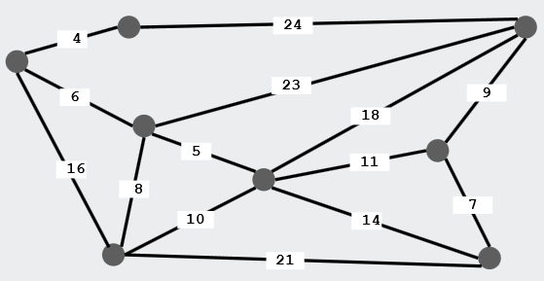

The miles between cities are shown on each branch. Determine a pipeline system that will connect all 10 cities, using the minimum number of miles of pipe, and indicate how many miles of pipe will be used.

**Maximum Flow Problems**

**Problem One**

1. Given the following network, with the indicated flow capacities along each branch, determine the maximum flow from source node 1 to destination node 10 and the flow along each path:

5

2

6

4

3

1

**Problem Two**

1. A company owns a factory located in city S where products are manufactured that need to be transported to the distribution center city T. You are given the one-way roads that connect pairs of cities in the country, and the maximum number of trucks that can drive along each road. What is the maximum number of trucks that the co. can send to the distribution center?

V

U

W

Z

T

S